Frogfruit (Creeping Charlie)

Phyla nodiflora
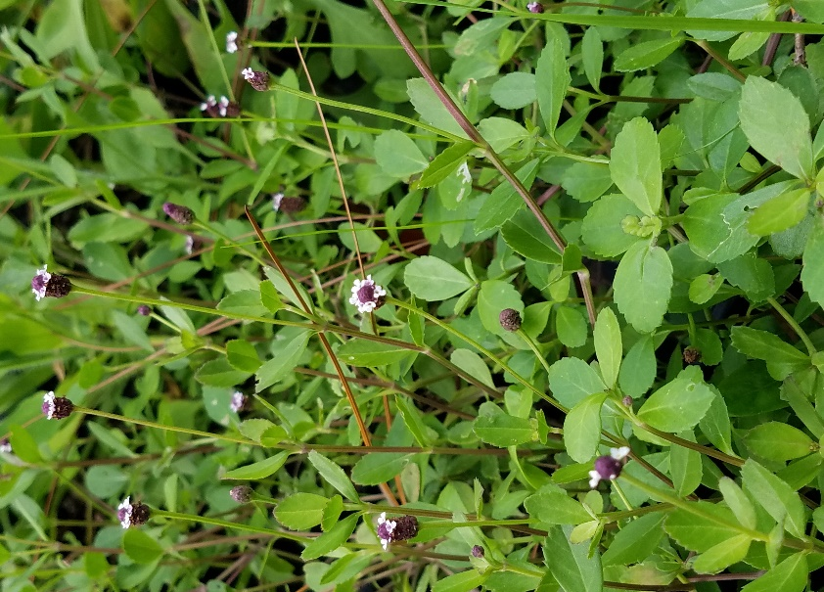

Family: Verbenaceae

Native Range: Central and South Florida; subtropical and tropical regions of the world

Description: Evergreen groundcover for lawn replacement

Flowering season: All year
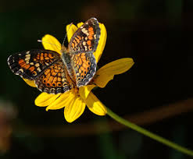
Exposure: Full sun to partial shade
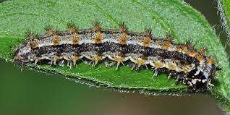
Moisture: Moist to dry
Highly Salt Tolerant
USDA Hardiness Zone: 8-11
Host to White Peacock, Phaon Crescent and
Common Buckeye Butterflies

